One Page Abstract Template for the VCSEL Day 2018

Austin Beck¹, Chelsea Cooper², and Oliver Stark¹
1. Ulm University, Institute of Optoelectronics, Albert-Einstein-Allee 45, 89081 Ulm, Germany
2. Philips GmbH U-L-M Photonics, Lise-Meitner-Straße 13, 89081 Ulm, Germany

E-mail: austin.beck@uni-ulm.de

This is a sample one page abstract for submissions to the VCSEL Day 2018, which will take place on April 12 and 13, 2018 in Ulm, Germany. The abstract should be submitted in Microsoft Word format (.docx) and must not exceed the one page limit. Please do not change the margins or the header and footer. Use only 10-point “Times New Roman” for text fonts. The figures can be provided in greyscale or colors. Figure captions should be centred beneath figures and in an 8-point font. References should appear at the end of the article in the order in which they are referenced in the body of the paper. The font should be 8-point and the references should be aligned left. A suggested format for references is given below.

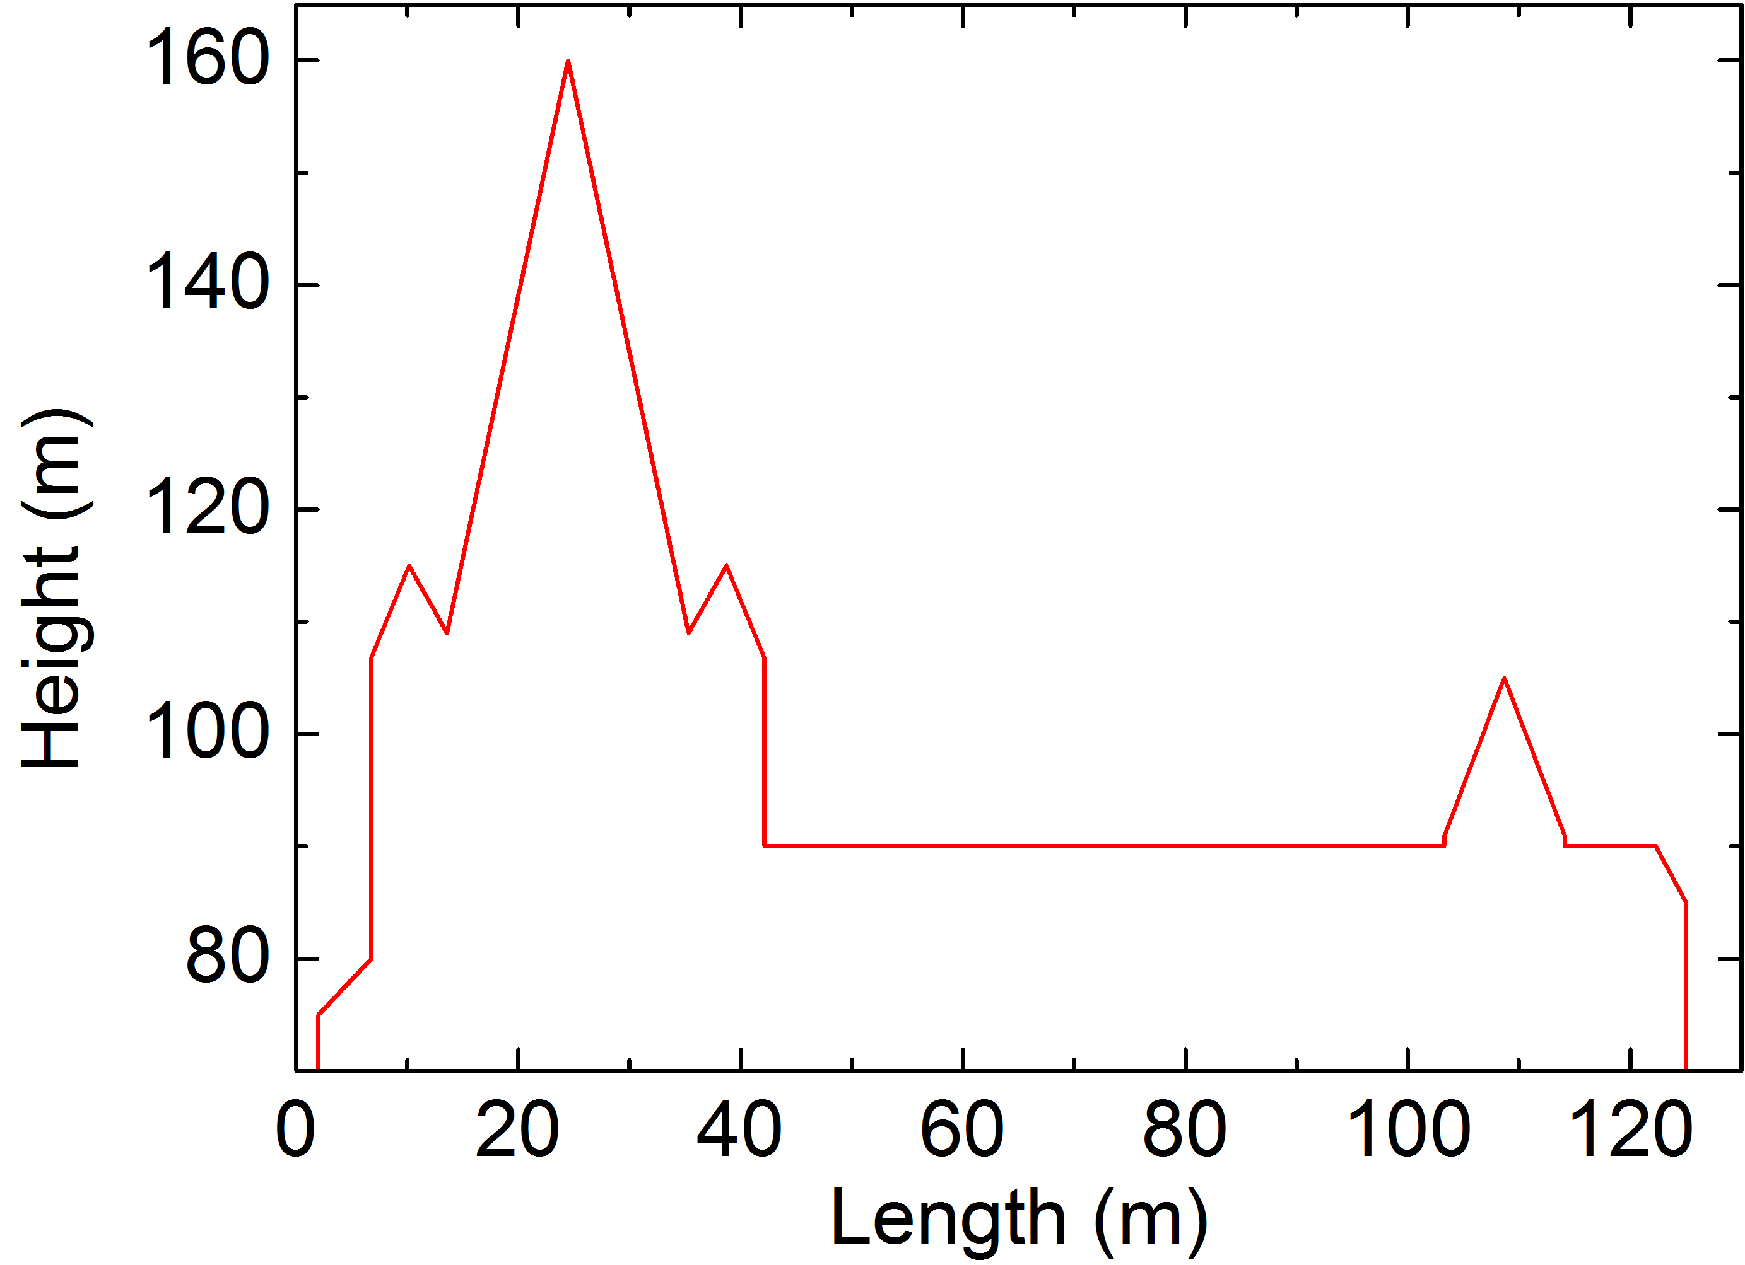

Fig. 1 Height profile of the Ulm Minster, one of the main tourist attractions in Ulm. With a steeple measuring 161.53 m, it is the tallest church in the world.

Please submit your abstract until March 16, 2018 via e-mail to vcselday2018@uni-ulm.de. Do not forget to register for the workshop at the website www.uni-ulm.de/en/in/institute-of-optoelectronics/vcselday2018. Further information about traveling to Ulm or hotel booking is offered there and will be updated continuously. We look forward to welcoming you in Ulm.
References
[1] D.M. Kuchta, Chap. 16 in VCSELs, R. Michalzik ed. (Springer, Berlin, 2013).
[2] H. Soda, K. Iga, C. Kitahara, and Y. Suematsu, "GaInAs/InP surface emitting injection lasers", Jpn. J. Appl. Phys. 18, 2329 (1979).

