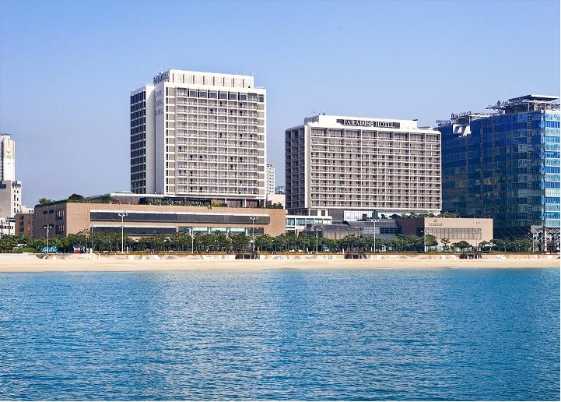
.
General information

- Transportation
The Paradise hotel is located on Haeundae beach taking 40 - 60 minutes’ drive (depending on traffic) from either Busan Station or Gimhae International Airport.

Please visit to Gimhae International Airport (http://www.airport.co.kr/mbs/gimhaeeng/) for your information.

- From Gimhae airport to Paradise Hotel Busan
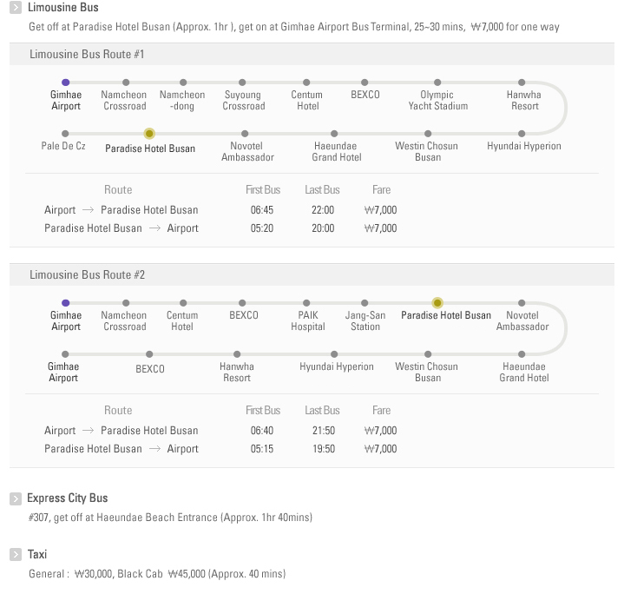

- From Busan Station to Paradise Hotel Busan
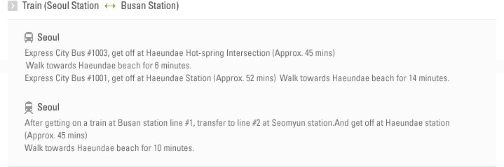

For detailed information about how to get to the meeting venue (Busan Paradise Hotel), please visit the website of Paradise Hotel at https://www.busanparadisehotel.co.kr/main.do?lang=en

< Map of Paradise Hotel>
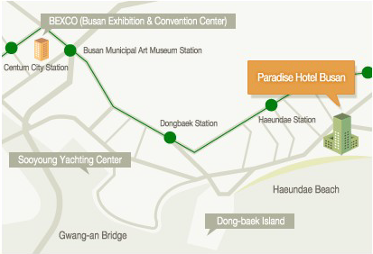
< Map of Busan Subway Lines>
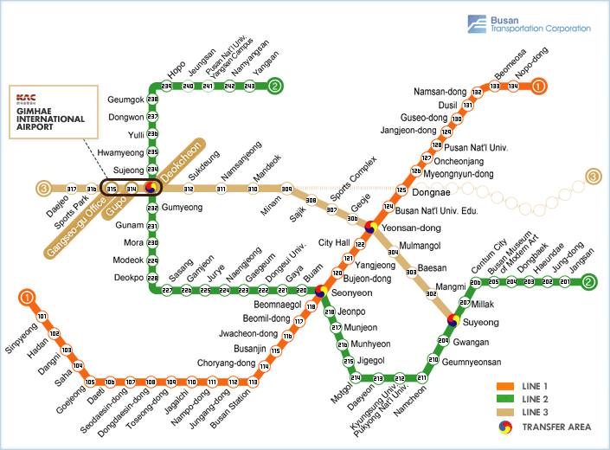
Paradise Hotel

2. VISA
Delegates are advised to check regulations regarding VISA. Related information can be obtained from the nearest Korean Embassy or Consulate as well as the following website:
http://www.mofat.go.kr/ENG/visa/application/index.jsp?menu=m_40_10
- Name
- Nationality
- Male or Female
- Date of birth (dd-mm-yyyy)
- Passport No. & Date of Expiry (dd-mm-yyyy)
- Company / Organization
- Your Designation / Title
- Address
- Tel/Fax
- E-mail

3. Currency and Credit Cards
The unit of Korean currency is Won. Coin denominations are 1 won, 5 won, 10 won, 50 won, 100 won, 500 won. Bank notes are 1,000 won, 5,000 won, 10,000 won and 50,000 won. Bank checks are circulated in denominations of 100,000 won and over.
Foreign currency and traveler's check can be converted into Korean won at foreign exchange banks and other authorized money exchangers. The exchange rate is subject to market fluctuations. One U.S dollar was equivalent to about 1,100 won as of November 2014.
Credit cards, including VISA, American Express, Diner’s Club, Master Card and JCB, are accepted at major hotels, department stores, and restaurants.

4. Electricity
The standard voltage in the Korea is 220 volts AC , 60 Hz with a round two-pin plug (same as in Germany or France). Always check the power supply before using your equipment.
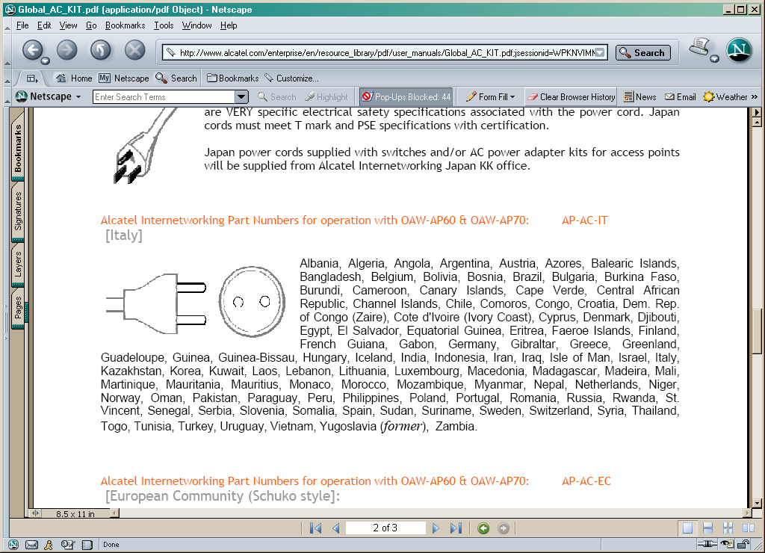

5. Sightseeing
Busan, a city where its mountains, rivers and the sea are in harmony, and exciting and abundant festivals and diverse international functions are held all the year round.
You’ll experience all the splendours of big city and the beauty of nature in Busan.

Useful Links
- Busan City Tour and information: http://english.busan.go.kr/index.jsp
- Inchon International Airport : http://www.airport.kr/eng/
- Gimpo Domestic Airport : http://www.airport.co.kr/mbs/gimpoeng/
- Gimhae International Airport: http://www.airport.co.kr/mbs/gimhaeeng/
- KOREAN Air : http://www.koreanair.com/
- ASIANA Airline : http://us.flyasiana.com

