Titel (in Calibri, 16 pt, bold)

Presenting author¹, Author,² Author¹ (in Calibri, 12 pt)

¹ Department, University, Country (in Calibri, 12 pt, italic)
² Department, University, Country

Text (please add your text including references [1] here) (in Calibri, 12 pt)
The text (including pictures and references should not exceed one page.

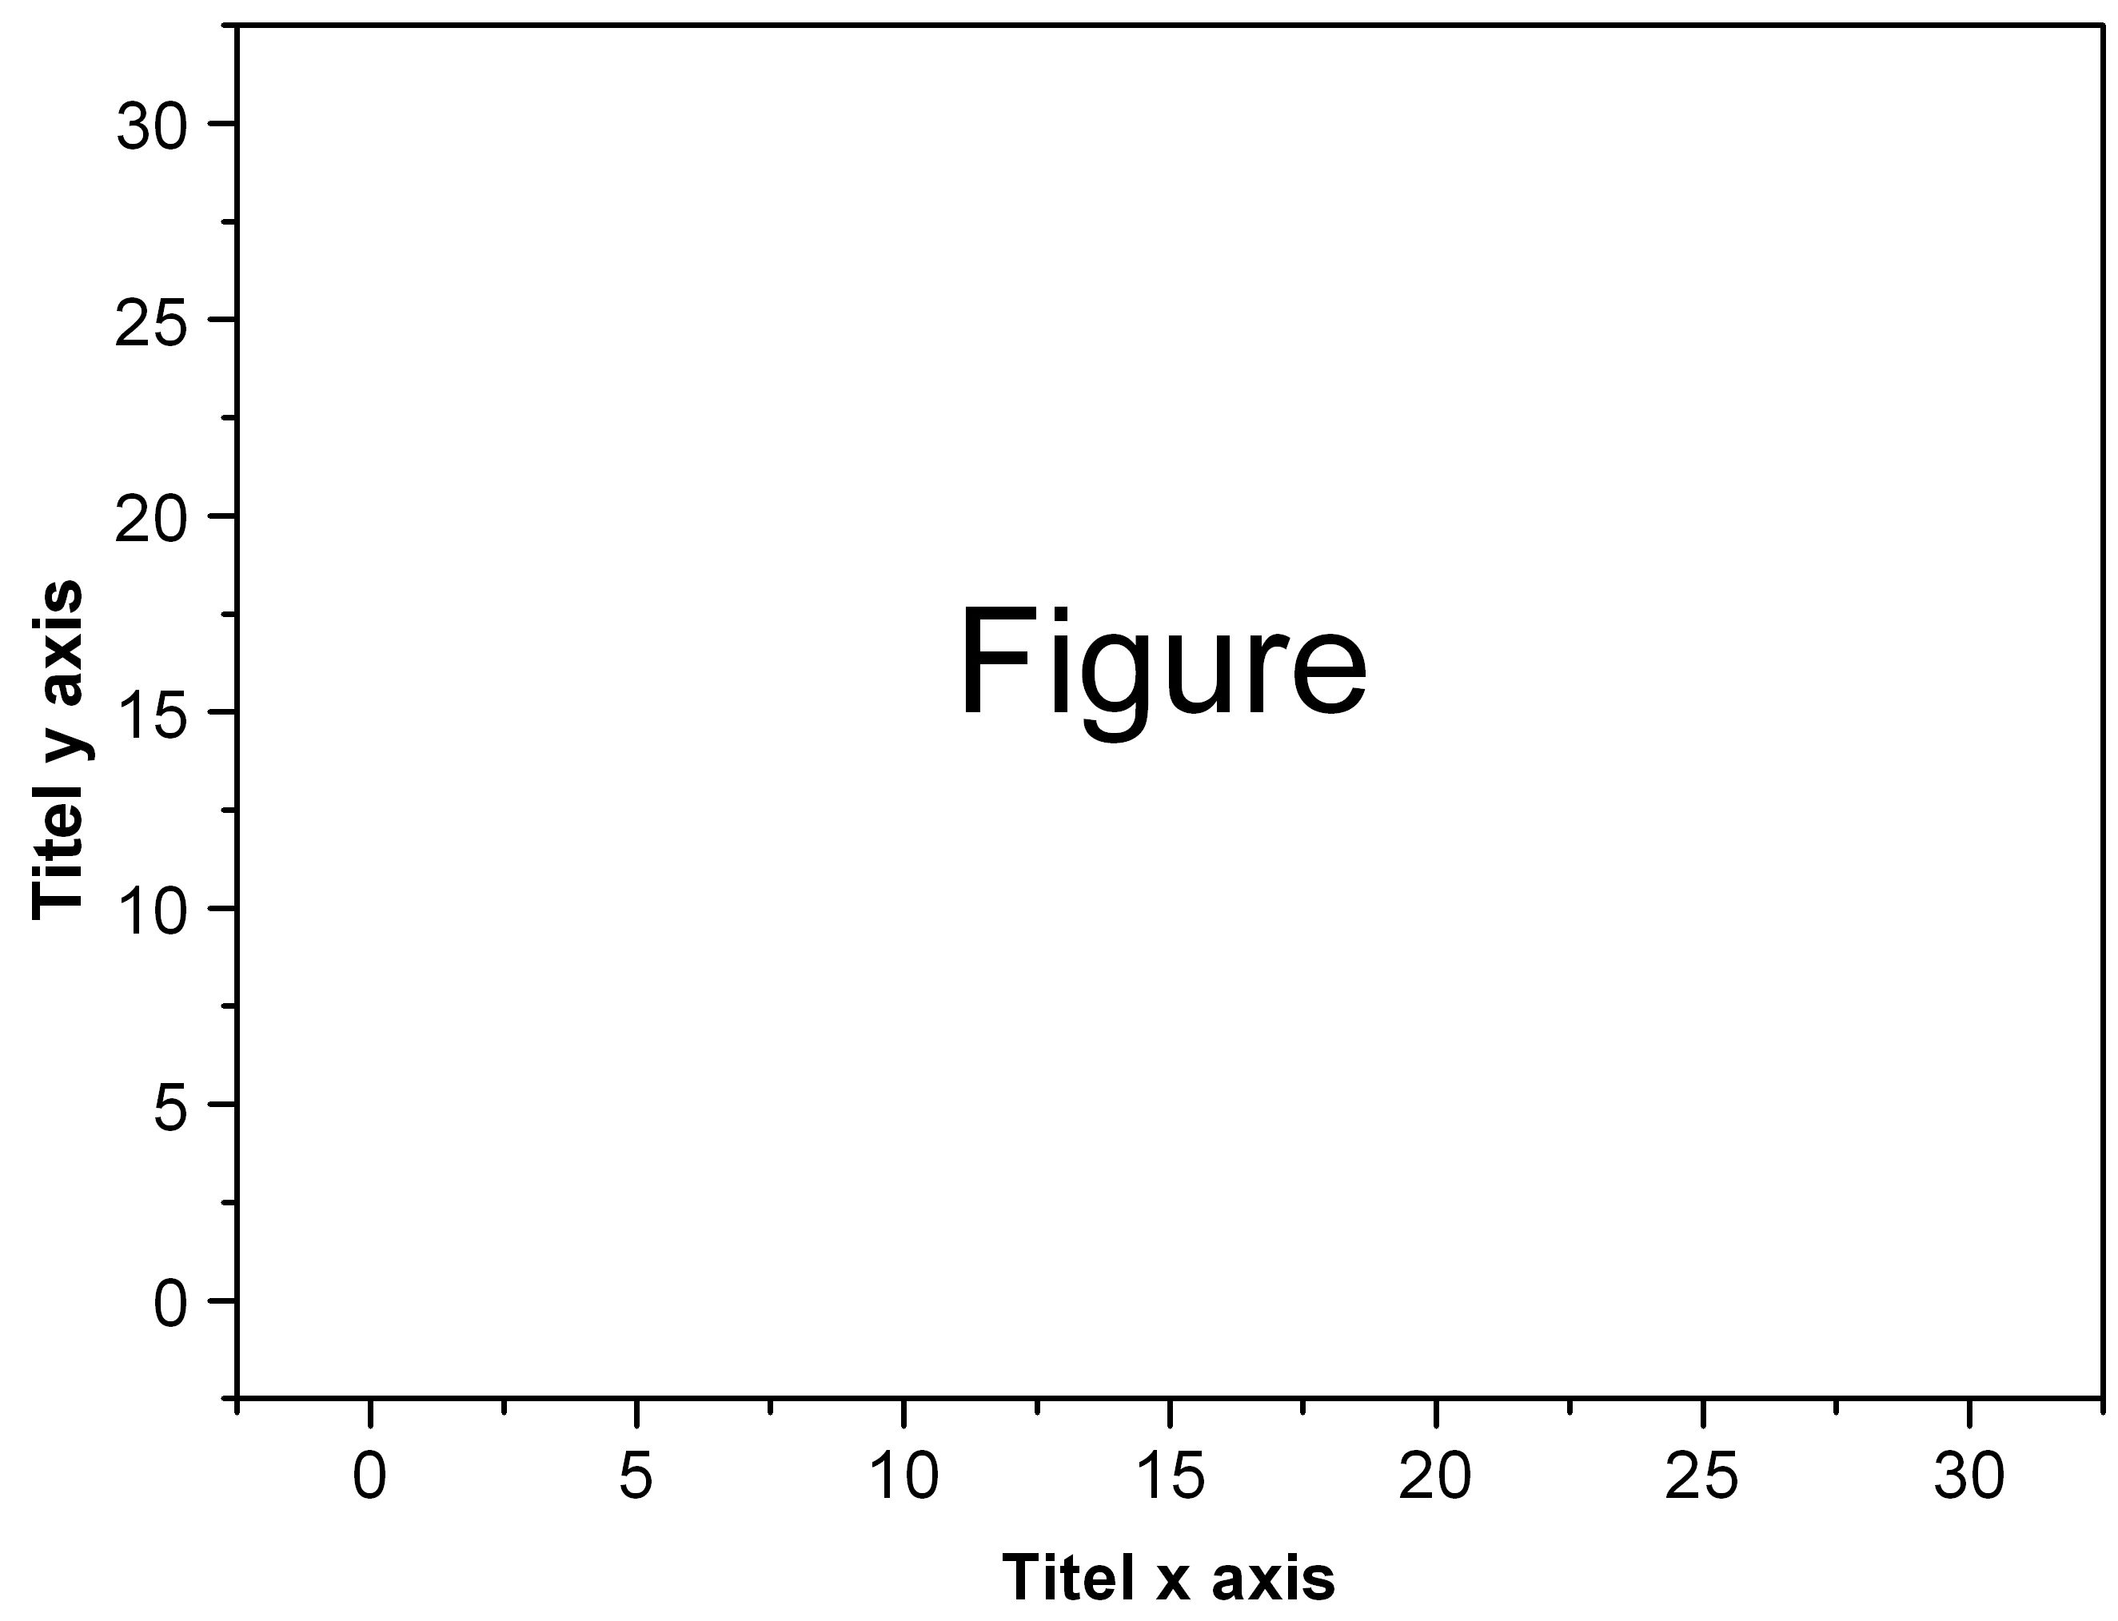
Figure 1: Please, add figure caption (in Calibri, 11 pt)

[1] N.N. Name, N.N. Name, Journal Volume (Year) Page (in Calibri, 10 pt)

