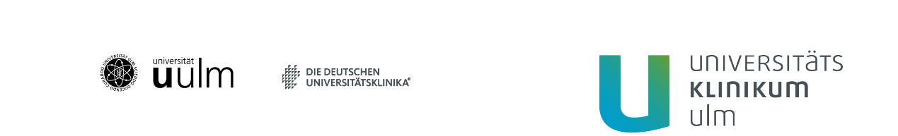
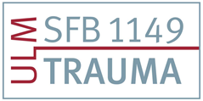
International Symposium CRC 1149
Registration Form
(Please fill in the form below)

Full Name Please click to fill in
Organization Please click to fill in
Address Please click to fill in
Please click to fill in
Please click to fill in
Phone Number Please click to fill in
E-Mail Please click to fill in

Attendance Symposium Number of participants
☐19.09.2022 Please click to fill in
☐20.09.2022 Please click to fill in
☐21.09.2022 Please click to fill in

We'll be attending the Conference Dinner on September 20, 2022 in the „Bootshaus“ with _________ people.

Registration by mail to: sfb.1149@uniklinik-ulm.de
Deadline: 30.06.2022

