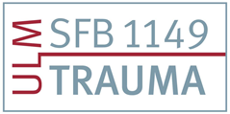
International Symposium CRC 1149
Registration Form
(Please fill in the form below)

Full Name Please click to fill in
Organization Please click to fill in
Address Please click to fill in
Please click to fill in
Please click to fill in
Mobile Phone Number Please click to fill in
E-Mail Please click to fill in

Attendance Symposium Number of participants
☐19.09.2022 Please click to fill in
☐20.09.2022 Please click to fill in
☐21.09.2022 Please click to fill in

I would like a 3-day ticket for public transport yes ☐ no ☐

I will be attending the Conference Dinner on September 20, 2022 in the „Bootshaus“.
yes ☐ no ☐

I will bring an accompanying person to the Conference Dinner Please choose
(Bringing an accompanying person will be charged with 60 €)

Registration by mail to: sfb.1149@uniklinik-ulm.de
Deadline: 26.08.2022

