Seminar organised by Animal Research Centre (Tierforschungszentrum), Ulm University
„Translation and experimental animal use: How we can improve?“
Date: 17th January 2019
Location: University Ulm, Building N27, Multimediaraum, Albert-Einstein-Allee 11, 89081 Ulm
Animal experiments resulted and still result in great medical success. But often the finding remains questionable. In the field of animal research the causal analysis is currently in debate.

In frame of this event following questions will be addressed and discussed:
Under which circumstances can animal experiments be translated to humans?
How quality and efficiency can be enhanced?
How reproducibility of animal models can be improved?
How repeat testing can be prevented?
How we can reduce the number of animals used in research?

09:15 - 9:30
Welcome
Dr. Inken Beck, Ulm University, Animal Research Centre

09:30 - 10:00
The use of animals in cancer research
Dr. Andrew Westhoff, Ulm University, Children and Youth Medicine, Apoptosis and Tumortherapy

10:10 - 11:40
Standard in the mouse house: quality and publication practise
Dr. Sibylle Ott, Ulm University, Animal Research Centre

11:50 - 12:20
From mouse to man: How to make the development of novel therapeutics more
successful
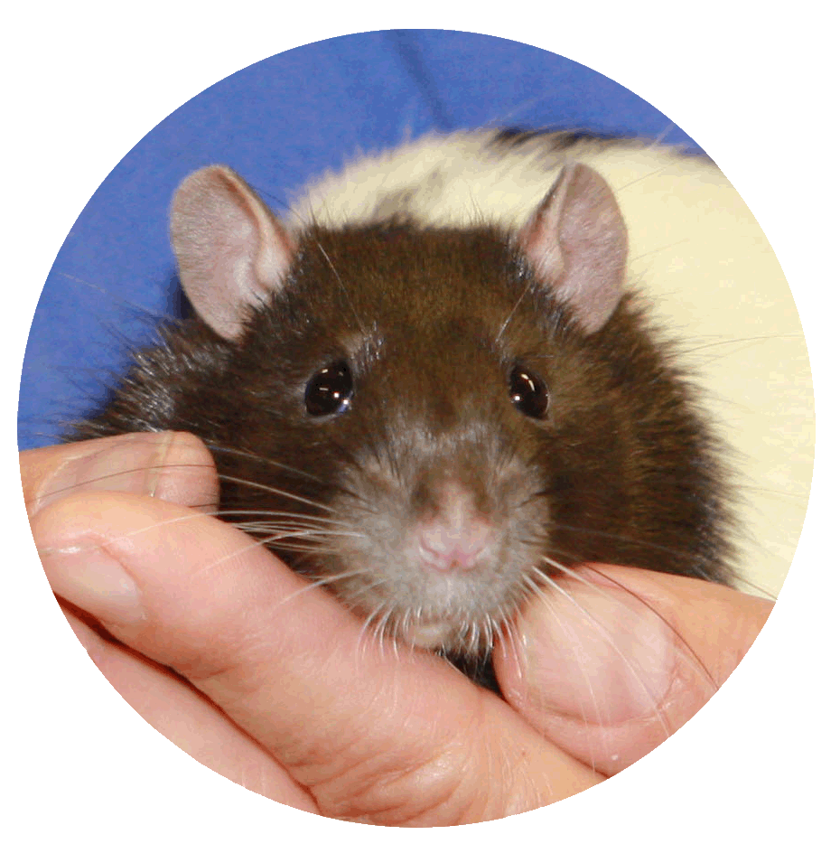
Prof. Ulrich Dirnagl, Charité Berlin, Experimental Neurology and BIH QUEST Center for Transforming, Biomedical Research

12:30 - 13:20 Lunch

13:20 - 13:50
Publish or perish: Challenges of Animal Research by Peer Review and Ethical Approvals
Prof. Jan Tuckermann, Ulm University, Institute of Comparative Molecular Endocrinology

14:00 - 14:30
The animal Intensive Care Unit - how to design animal experiments in shock research
Prof. Peter Radermacher, Ulm University, Institute of Anaesthesiological Pathophysiology and Process Engineering

14:30-14:50
Final discussion
Presentations in English, discussion in English and/or German

Registration and invoice
(10 € members of Ulm University // 12€ non-members (incl. MwSt))

Dr. Inken Beck (Leitung)

Tel.: +49 (0)731 / 50 - 25591
Fax: +49 (0)731 / 50 - 25589

E-Mail: sekretariat.tfz@uni-ulm.de

Universität Ulm | Tierforschungszentrum | 89081 Ulm | Germany

Anmeldung und Rechnung zu der Veranstaltung
„Translation and experimental animal use: How we can improve?“
vom Tierforschungszentrum der Universität Ulm
am Donnerstag,17. Januar 2019

Teilnehmerdaten
Frau | Herr
Titel *:
Nachname: |  | Vorname:
Universität / Firma: |  | E-Mail
Telefon:

Rechnung
Angestellte der Universität und des Universitätsklinikums Ulm 10,00 €
Externe Teilnehmer 12,00 € (inkl. MwSt.)

Bitte überweisen Sie den Rechnungsbetrag sofort nach Bestätigung der Anmeldung
auf folgendes Konto:
Kontoinhaber: Kasse der Universität Ulm
Bundesbank Ulm
BIC (SWIFT-Code): MARKDEF1630
IBAN: DE72 6300 0000 0063 0015 05

___________________ _____
Ort, Datum Unterschrift

Anmeldung per Post, FAX oder E-Mail.
Veranstaltungsort: Universität Ulm, Multimediaraum N27, Raum-Nr. 2059,Meyerhofstraße, 89081 Ulm

