Profiles of candidates
In order to give voters an idea of the candidates, profiles of the candidates can be published on the University' internal network. In addition to the basic details of your election proposal (surname, first name, Faculty and name of election proposal), you can voluntarily provide us with a picture of yourself, your study programme or your institute/facility as well as information on your goals and motivation for your candidacy. If we do not receive such information from you, we will only introduce you with your surname, first name, title (if applicable), Faculty and name of the election proposal (see example on page 2).

Name of your election proposal:

Your (title) surname, first name:

Faculty, institute, facility; study programme in case of students:

Goals and motivation (max. 250 characters, with spaces; no links)

Consent to the publication of my photo
I agree that the photo I have provided may be published in the University's internal network as part of the 2023 University elections for the profiles.

I declare my consent to the use of the photographs of my person for the purpose described above.
The use of the data or the photographs for purposes other than those described above or the circulation of the photographs to third parties is not permitted.
I was adequately informed about the associated internet risks by the "Important information on consent to the publication of personal data on the internet" formulated overleaf.

Revocation policy:
This consent within the meaning of Art. 6 (1) a) in conjunction with Art. 7 DSGVO can be withdrawn in writing at any time without giving reasons. Insofar as the consent is not withdrawn, it is valid for an unlimited period of time, i.e. also beyond the end of the employment relationship. The legality of the data processing carried out until the withdrawal remains unaffected by the withdrawal. The consent is voluntary. No disadvantages arise from the refusal of consent or its withdrawal.
Please address any withdrawal to:
wahlen@uni-ulm.de
With my signature, I confirm the release of the above data for internal or external use and declare that I have read and understood the above revocation policy and the information on data protection.

Place, date |  | Signature

Please send the above details and your photo/s in a common format (jpg, png etc).
By email to wahlen@uni-ulm.de

by 23 May 2023, 3 p.m.

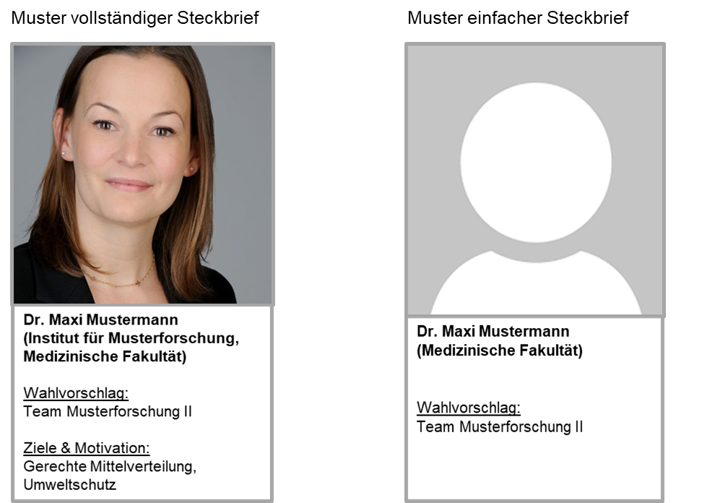
Important information on consent to the publication of personal data on the internet
The consent of persons to the publication of photos is one of the requirements that must be fulfilled (Art. 6 para. 1 letter a) in conjunction with Art. 7 DSGVO and § 22 Art Copyright Act, right to one's own image) in order to allow photos to be published on the internet.
As part of the consent, the persons concerned must be comprehensively informed about the dangers of publication on the internet.
The following risks are hereby expressly pointed out.
- The possibility of national and international retrieval of the data posted on the internet from the public and non-public sectors. The data stock advances to become a generally accessible source worldwide.
- Endangering the employees' right to informational self-determination when their data is published worldwide. This can arise from the fact that the data can also be accessed in countries where there is no or no sufficient data protection standard. This means that an adequate level of data protection cannot be ensured in every case.
- The posted data can be read unnoticed and stored, changed, falsified, combined or manipulated in many ways.
- There is the possibility of a worldwide automated evaluation of the publication according to different search criteria, which can be linked with each other as desired (e.g. creation of a meaningful personality profile by combining information about the professional position, the area of responsibility of the persons with data from the private context).
- Commercial use, e.g. risk of unsolicited mail and harassment.
- By making the data publicly available, the examination of the legitimate interest of the recipient in knowing the data is waived.
- Once the data has been stored, the recipient may continue to use the data even if the providing body has already changed or deleted its internet offer.
The consent of the data subject must be obtained in writing and prior to publication.

Legal texts
§ 22 Art Copyright Act (Kunsturheberrechtsgesetz)
Portraits may only be distributed or publicly displayed with the consent of the person portrayed. In case of doubt, consent shall be deemed to have been granted if the person portrayed received remuneration for having his or her image reproduced. After the death of the person portrayed, the consent of the relatives of the person portrayed is required for a period of 10 years.
Relatives within the meaning of this Act are the surviving spouse or civil partner and the children of the person depicted and, if there is neither a spouse or civil partner nor children, the parents of the person depicted.

Art. 6 para. 1 letter a) of the General Data Protection Regulation
- Processing shall be lawful only if and to the extent that at least one of the following applies:
- the data subject has given consent to the processing of his or her personal data for one or more specific purposes;
Art. 7 of the General Data Protection Regulation
- Where processing is based on consent, the controller shall be able to demonstrate that the data subject has consented to processing of his or her personal data.
- If the data subject’s consent is given in the context of a written declaration which also concerns other matters, the request for consent shall be presented in a manner which is clearly distinguishable from the other matters, in an intelligible and easily accessible form, using clear and plain language. Any part of such a declaration which constitutes an infringement of this Regulation shall not be binding.
- Any part of such a declaration which constitutes an infringement of this Regulation shall not be binding. The withdrawal of consent shall not affect the lawfulness of processing based on consent before its withdrawal. Prior to giving consent, the data subject shall be informed thereof. It shall be as easy to withdraw as to give consent.
- When assessing whether consent is freely given, utmost account shall be taken of whether, inter alia, the performance of a contract, including the provision of a service, is conditional on consent to the processing of personal data that is not necessary for the performance of that contract.

